
Umm Al Qura University
College of Computing
Software Engineering Department

Project Title

MSARE

Multi-System for Arena Real-time Experience

A project submitted

in partial fulfillment of the requirements for the degree of Bachelor in Software Engineering

by

Basil Al-harbi (445003541)
Raed Al-Harbi (445013854)
Abdulmohsen Alkediwi (445003683)
Abdulmajeed Abdulrahim (445001556)

Supervised by

Dr. Mohammed Noor

Month Year

December 2025

Declaration

This is to declare that the project entitled “MSARE – Multi-System for Arena Real-time Experience” is an original work done by the undersigned, in partial fulfillment of the requirements for the degree of Bachelor of Software Engineering at the Software Engineering Department, College of Computer and Information Systems, Umm Al-Qura University.

All the analysis, design, and system development have been accomplished by the undersigned. Moreover, this project has not been submitted to any other college or university.

Basil Al-Harbi ________________

Raed Al-Harbi ________________

Abdulmohsen Alkediwi ________________

Abdulmajeed Abdulrahim ________________

Note: sign across your name

ABSTRACT

Large-scale stadiums often face challenges related to parking management, navigation, and crowd congestion during major events. Fans usually struggle to find suitable parking, navigate efficiently to their seats, and exit the venue smoothly after events. Existing navigation applications lack support for seat-based routing, indoor navigation, and real-time congestion awareness.

This project proposes MSARE (Multi-System for Arena Real-time Experience), a smart system designed to enhance the fan journey from arrival to departure. MSARE provides smart parking recommendations based on seat location and congestion levels, indoor and outdoor navigation with optional facility stops, and real-time exit guidance using gate congestion data. The system targets stadium visitors and event attendees to improve overall experience, reduce delays, and enhance safety. MSARE offers a more integrated and crowd-aware solution compared to existing navigation systems.

ACKNOWLEDGMENT

The project team would like to express their sincere gratitude to our supervisor, Dr. Mohammed Noor, for his continuous guidance, valuable feedback, and support throughout the development of this project. We would also like to thank our instructors for their guidance and the Software Engineering Department at Umm Al-Qura University for providing the necessary resources and learning environment. Finally, we extend our appreciation to our families and friends for their encouragement and support.

CONTENT
Undertaking ii
ABSTRACT III
Acknowledgment iv
List of Tables vi
List of Figures vii
List of Acronyms and Abbreviations viii
CHAPTER 1: INTRODUCTION 9
  - Overview 9
  - Background 9
  - Problem Statement 10
  - Project Aim and Objectives 10
  - Related Existing Systems 10
CHAPTER 2: Planning phase 11
  - Scope of the project 11
  - Project risks and Product risks 11
  - Project Schedule 11
  - Project Software and Hardware Requirements 12
CHAPTER 3: Requirements 13
  - Used Techniques For Requirements Collection 13
  - Functional Requirement & Modelling 13
    - List of System Functions (Features) 13
    - Use Case Diagram 13
    - Use Cases: Description & Details 14
  - Nonfunctional Requirements: Quality & Constriants 14
CHAPTER 4: System Architecture & Design 15
  - Software Architecture 15
  - Software Detailed Design 16
    - Use Cases Internal Interactions as Sequence Diagrams 16
    - Class Diagram 16
    - Data Storage Organization 16
  - User Interface Prototyping 16
Conclusions 18
REFERENCES 19

LIST OF TABLES
Table 1: Table Example 14

LIST OF FIGURES
Figure 1: System Overview 15

LIST OF ACRONYMS AND ABBREVIATIONS
API Application Programming Interface
REST Representational State Transfer WS
RPC Remote Procedure Call
GPS Global Positioning System
UI User Interface
UX User Experience
MSARE Multi-System for Arena Real-time Experience
NFR Non-Functional Requirement
FR Functional Requirement

CHAPTER 1: INTRODUCTION

This chapter introduces the MSARE project and presents its background, motivation, problem statement, objectives, and relation to existing systems. The chapter aims to provide a clear understanding of the problem domain and the significance of the proposed solution, as well as an overview of how the report is organized.

Overview

MSARE (Multi-System for Arena Real-time Experience) is a smart system designed to enhance the experience of fans attending large stadium events. The system focuses on improving the fan journey from arrival to departure by providing smart parking recommendations, indoor and outdoor navigation, crowd-aware routing, and intelligent exit guidance. By integrating real-time data and navigation technologies, MSARE helps reduce congestion, save time, and improve safety within stadium environments.

Project Motivation

The motivation behind developing the MSARE project stems from the challenges faced by fans during large stadium events, particularly in parking management, navigation, and crowd congestion. Existing navigation systems are not specifically designed for stadium environments and do not provide seat-based guidance, indoor navigation, or real-time crowd awareness. This often results in delays, confusion, and reduced user satisfaction.

The importance of this project lies in its focus on improving the overall fan experience and safety by offering an integrated solution that supports the entire journey from arrival to departure. The new idea proposed by MSARE is the combination of smart parking recommendations, indoor and outdoor navigation, optional facility stops, and real-time crowd-aware routing within a single system tailored specifically for large event venues.

Problem Statement

Fans attending large stadium events face several challenges related to parking availability, navigation, and crowd congestion. Many visitors struggle to find suitable parking areas, navigate efficiently from parking zones to their seats, and exit the stadium smoothly after events. Current navigation applications mainly focus on outdoor routing and do not support seat-based guidance, indoor navigation, or real-time adaptation to crowd conditions.

As a result, fans experience delays, confusion, overcrowding, and reduced safety during events. There is a clear gap between the current situation, where navigation and parking management are fragmented and inefficient, and the desired state, where fans can be guided seamlessly throughout their entire journey. This project addresses this gap by proposing an integrated, smart system that improves navigation efficiency, reduces congestion, and enhances the overall stadium experience.

Project Aim and Objectives

The main aim of this project is to design and propose a smart system that enhances the experience of fans attending large stadium events by improving navigation efficiency, reducing congestion, and increasing overall safety.

This project achieves its aim through the following objectives:
- Provide smart parking recommendations based on the fan’s seat location and real-time congestion levels.
- Enable seamless indoor and outdoor navigation within stadium environments.
- Reduce crowd congestion by using real-time data and adaptive routing.
- Assist fans in locating stadium facilities during their journey.
- Support efficient and safe exit guidance after events.
- Improve the overall user experience by offering an integrated and easy-to-use navigation solution.

Related Existing Systems

Several existing systems and applications provide navigation and routing services for users. Popular solutions such as Google Maps and Apple Maps offer reliable outdoor navigation and traffic-aware routing for city environments. However, these systems are mainly designed for road navigation and do not support indoor navigation, seat-based guidance, or real-time crowd awareness within large stadiums.

Some stadium-specific applications focus on ticket management, event information, and static venue maps. While these applications help users access basic information, they lack intelligent routing, smart parking recommendations, and dynamic adaptation to crowd congestion. In addition, certain research-based indoor navigation systems rely on technologies such as Bluetooth beacons or Wi-Fi positioning, but they are often limited in scope and do not provide end-to-end journey support.

MSARE distinguishes itself from existing systems by offering a comprehensive and integrated solution tailored specifically for stadium environments. Unlike traditional navigation applications, MSARE combines smart parking recommendations, indoor and outdoor navigation, optional facility routing, and real-time crowd-aware exit guidance within a single system, providing a complete fan journey from arrival to departure.

CHAPTER 2: PLANNING PHASE

Scope of the project

The scope of the MSARE project defines the boundaries and functionalities of the proposed system and clarifies what the project aims to accomplish. MSARE focuses on improving the fan journey within large stadium environments, starting from arrival and parking, through navigation to the seat, and ending with safe and efficient exit after events.

The system provides smart parking recommendations based on seat location and real-time congestion data, supports indoor and outdoor navigation within the stadium, enables crowd-aware routing, and assists fans in locating facilities such as restrooms and food areas. In addition, MSARE offers intelligent exit guidance by recommending the least congested gates after events.

The scope of the project includes stadium visitors as the primary stakeholders, along with stadium management as secondary stakeholders who may benefit from improved crowd flow and safety. External entities interacting with the system include mapping services, real-time congestion data sources, and mobile devices used by fans.

Out of scope for this project are ticket purchasing, payment processing, and event scheduling functionalities. The responsibilities of the project team include requirements analysis, system design, and prototype development. Project completion will be verified through documentation review, use case validation, and prototype demonstration.

Project risks and Product risks

During the development of the MSARE project, several project and product risks may be encountered. Project risks are related to planning, resources, and time management, while product risks are associated with system functionality, performance, and quality.

One of the main project risks is schedule delay due to limited development time or coordination challenges among team members. Another risk involves incomplete or changing requirements, which may affect system design and implementation. Technical skill limitations or unfamiliarity with certain tools and technologies may also impact development progress.

Product risks include inaccuracies in real-time congestion data, which could reduce the effectiveness of routing recommendations. Indoor positioning limitations may affect navigation accuracy within stadium environments. Performance issues may arise when handling a large number of concurrent users during major events. Security and privacy risks related to user location data must also be considered.

To mitigate these risks, the project team plans to apply effective time management, clearly define requirements, conduct regular reviews, and use reliable technologies. Performance testing, data validation, and basic security measures will be applied to reduce potential negative impacts on the system.

Project Schedule

The project schedule outlines the timeline and key milestones required to complete the MSARE project successfully. The project is divided into several phases, starting with requirements analysis and planning, followed by system design, implementation, testing, and documentation.

A Gantt chart is used to represent the project timeline, task durations, and dependencies between project phases. This schedule helps ensure that all project activities are completed within the planned timeframe and allows progress to be monitored effectively.
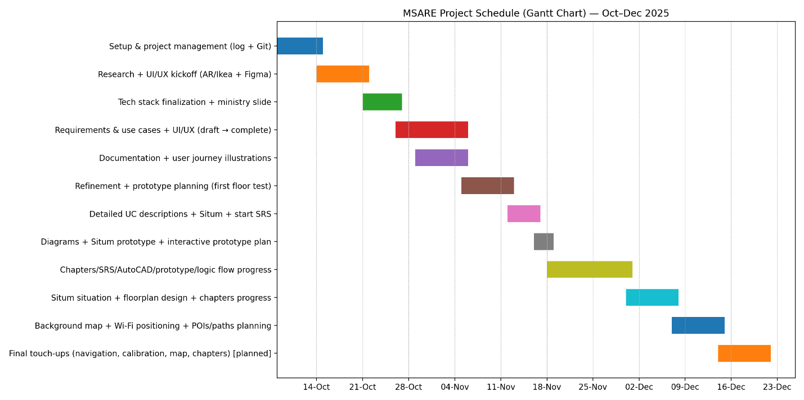

Project Software and Hardware Requirements

The development of the MSARE project requires several software and hardware resources to support design, implementation, and testing activities.

Software Requirements include development tools such as Visual Studio Code for coding, Figma for user interface prototyping, and GitHub for version control and collaboration. Mobile application development tools such as Flutter and related SDKs are used to develop the client-side application. External services such as mapping APIs and cloud-based real-time data sources are utilized to support navigation and congestion awareness.

Hardware Requirements include personal computers or laptops for development and testing, as well as smartphones for testing the mobile application. An internet connection is required to access cloud services, APIs, and collaborative development tools.

CHAPTER 3: REQUIREMENT ENGINEERING AND ANALYSIS

Used Techniques For Requirements Collection

Several requirement elicitation techniques were used to collect and analyze the requirements of the MSARE project. These techniques helped in identifying stakeholder needs and translating them into clear and documented system requirements.
One of the main techniques used was stakeholder analysis, where the primary stakeholders, such as stadium visitors (fans), and secondary stakeholders, such as stadium management, were identified. Understanding their needs helped define the main system features and constraints.
Use case analysis was also applied to capture functional requirements. By describing user interactions with the system through use cases, the project team was able to clearly define system behavior, inputs, and expected outputs for key scenarios such as parking recommendation, navigation, and exit guidance.
In addition, literature review and analysis of existing systems were conducted to study similar solutions and identify their limitations. This helped refine the project requirements and propose improved features tailored to stadium environments.
All collected requirements were documented and reviewed to ensure consistency, clarity, and alignment with the project objectives.

Functional Requirement & Modelling

Functional requirements describe the core services and functions that the MSARE system must provide to its users. These requirements define how the system behaves in response to user inputs and specify the expected outputs for each function.

The MSARE system provides several key functional services, starting with allowing fans to input their seat information in order to receive smart parking recommendations based on proximity and real-time congestion levels. The system also enables users to navigate from parking areas to their seats using indoor and outdoor navigation features. During navigation, users can optionally select facilities such as restrooms or food areas, and the system recalculates the route accordingly.

In addition, the system supports real-time crowd-aware routing to avoid congested areas and improve movement efficiency. After the event, MSARE allows users to return to their saved parking location and provides smart exit guidance by recommending the least congested exit gates.

These functional requirements are modeled using UML diagrams, including use case diagrams and sequence diagrams, to clearly represent user interactions, system behavior, and the flow of information between system components.

List of System Functions (Features)

The MSARE system provides the following key features:
- Smart parking recommendation based on seat location and real-time congestion levels.
- Indoor and outdoor navigation from parking areas to stadium seats.
- Crowd-aware routing to avoid congested paths during movement.
- Optional facility routing to locations such as restrooms, food areas, and prayer rooms.
- Real-time congestion visualization within stadium areas.
- Parking location saving and retrieval for post-event navigation.
- Smart exit guidance by recommending the least congested exit gates.
- User-friendly mobile interface for navigation and guidance.

Use Case Diagram

The use case diagram below illustrates the main interactions between the primary actor (Fan) and the MSARE system. It presents an overview of the system’s functional capabilities, including smart parking recommendation, navigation to seats, crowd-aware routing, optional facility stops, and smart exit guidance. The diagram provides a high-level view of how users interact with the system to complete their journey within the stadium environment.

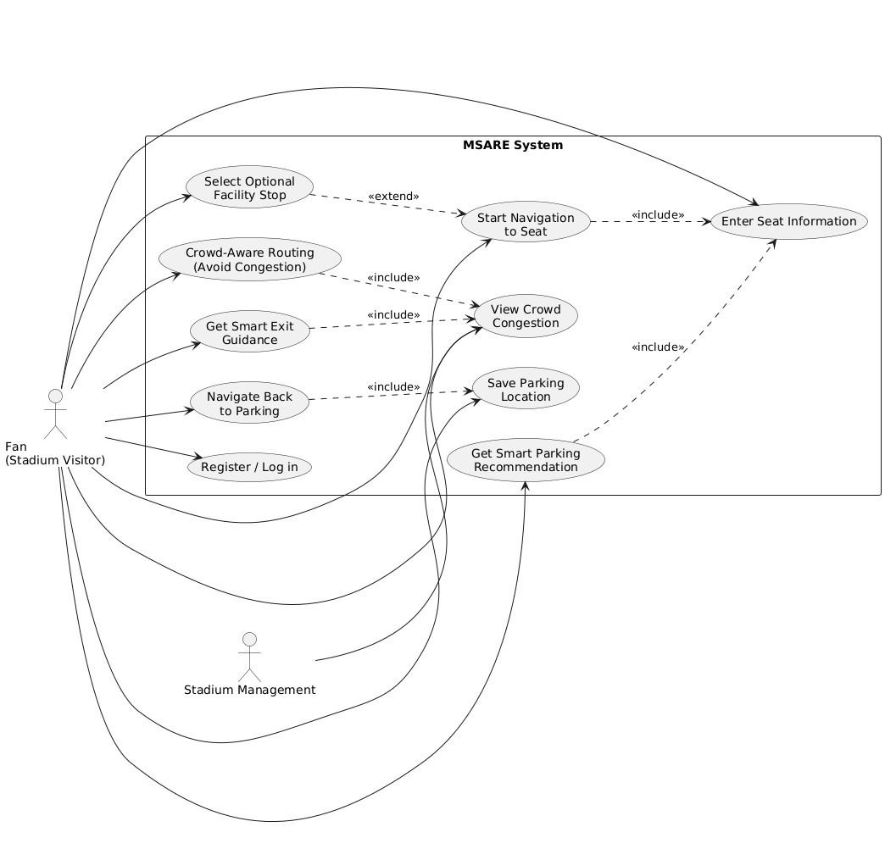

Figure 2: MSARE Use Case Diagram

Use Cases: Description & Details

This section provides detailed descriptions of the main use cases identified in the MSARE system. Each use case includes the main flow of events and possible alternative flows to describe normal and exceptional system behavior.

Use Case Name: Enter Seat Information
Primary Actor: Fan
Description: Allows the fan to enter seat details to enable personalized navigation and parking recommendations.

Main Flow:
1. The fan opens the MSARE application.
2. The fan enters the seat number.
3. The system validates the seat information.
4. The system stores the seat location for further processing.

Alternative Flow:
- If the seat number is invalid, the system displays an error message and requests re-entry.

Use Case Name: Get Smart Parking Recommendation
Primary Actor: Fan
Description: Provides the fan with the most suitable parking area based on seat location and congestion level.

Main Flow:
1. The system retrieves the fan’s seat location.
2. The system collects real-time parking congestion data.
3. The system analyzes distance and congestion.
4. The system displays the recommended parking area.

Alternative Flow:
- If real-time data is unavailable, the system provides a recommendation based on distance only.

Use Case Name: Start Navigation to Seat
Primary Actor: Fan
Description: Guides the fan from the parking area to the assigned seat.

Main Flow:
1. The fan starts navigation.
2. The system generates a route to the seat.
3. The system provides step-by-step guidance.
4. The fan reaches the seat successfully.

Alternative Flow:
- If the route is blocked, the system recalculates an alternative path.

Use Case Name: Select Optional Facility Stop
Primary Actor: Fan
Description: Allows the fan to include a facility stop during navigation.

Main Flow:
1. The fan selects a facility (e.g., restroom or food area).
2. The system updates the navigation route.
3. The fan visits the selected facility.
4. The system resumes navigation to the seat.

Alternative Flow:
- If the selected facility is unavailable, the system suggests alternative facilities.

Use Case Name: Save Parking Location
Primary Actor: Fan
Description: Saves the parking location for post-event navigation.

Main Flow:
1. The system automatically detects the parking location.
2. The system saves the location.
3. The fan receives confirmation.

Alternative Flow:
- If location detection fails, the fan can save the parking location manually.

Use Case Name: Get Smart Exit Guidance
Primary Actor: Fan
Description: Assists the fan in exiting the stadium efficiently after the event.

Main Flow:
1. The fan requests exit guidance.
2. The system retrieves real-time exit gate congestion data.
3. The system recommends the least congested gate.
4. The fan follows the guidance and exits the stadium.

Alternative Flow:
- If congestion data is unavailable, the system recommends the nearest exit gate.

Nonfunctional Requirements: Quality & Constraints

Nonfunctional requirements define the quality attributes and constraints of the MSARE system. These requirements specify how the system should perform rather than what functions it should provide. They ensure that the system is secure, reliable, efficient, and user-friendly.

Table 1: Nonfunctional Requirements of the MSARE System

NFR ID | Quality Attribute | Description | Priority | Constraint
NFR-1 | Performance | The system shall provide navigation and parking recommendations with minimal response time during peak stadium events. | High | Real-time data availability
NFR-2 | Scalability | The system shall support a large number of concurrent users during major events without performance degradation | High | Server and network capacity
NFR-3 | Reliability | The system shall operate continuously during events with minimal downtime or failures. | High | Network stability
NFR-4 | Usability | The system shall provide an intuitive and easy-to-use interface suitable for all users. | Medium | Mobile device compatibility
NFR-5 | Security | The system shall protect user data, including location and seat information, from unauthorized access | High | Real-time data availability

CHAPTER 4: SYSTEM ARCHITECTURE & DESIGN

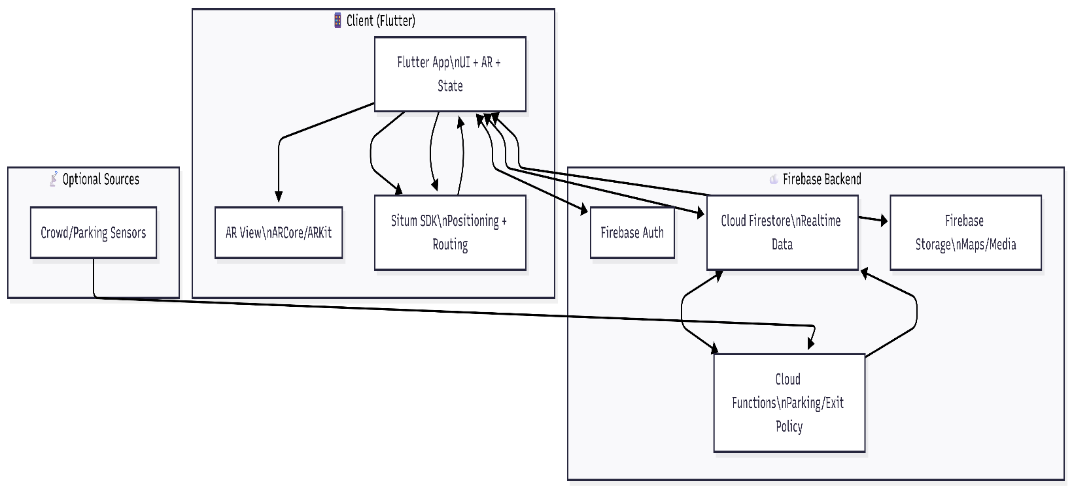
Software Architecture

Figure 1: System Overview

Software Detailed Design

Use Cases Internal Interactions as Sequence Diagrams

UCE 1 : Enter Seat information

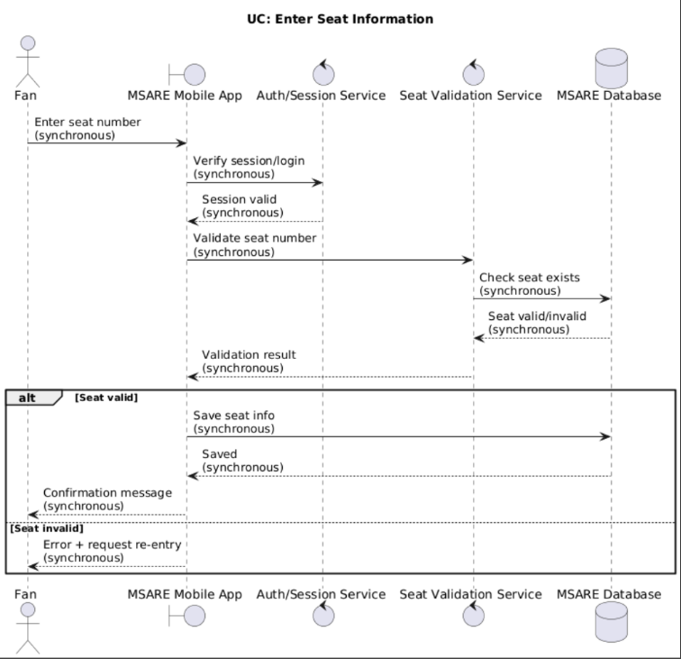

UCE 2 : Get Smart Parking Recommendation
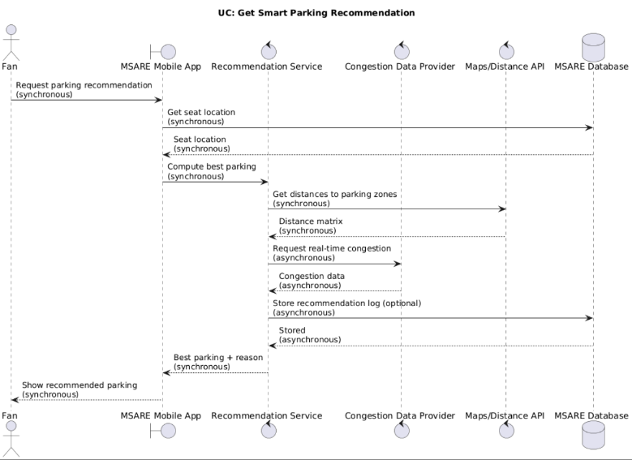

UCE 3 : Start Navigation to Seat

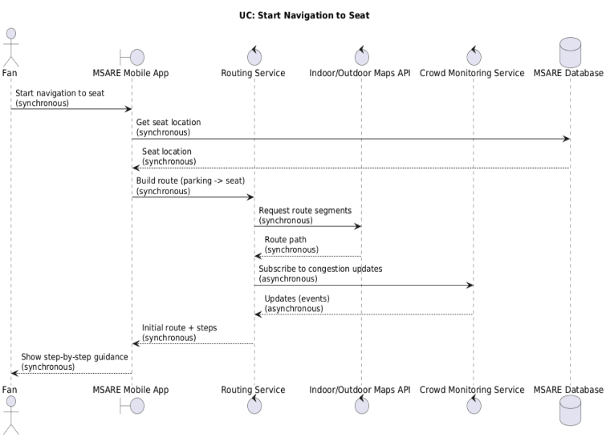

UCE 4 : Select Optional Facility Stop

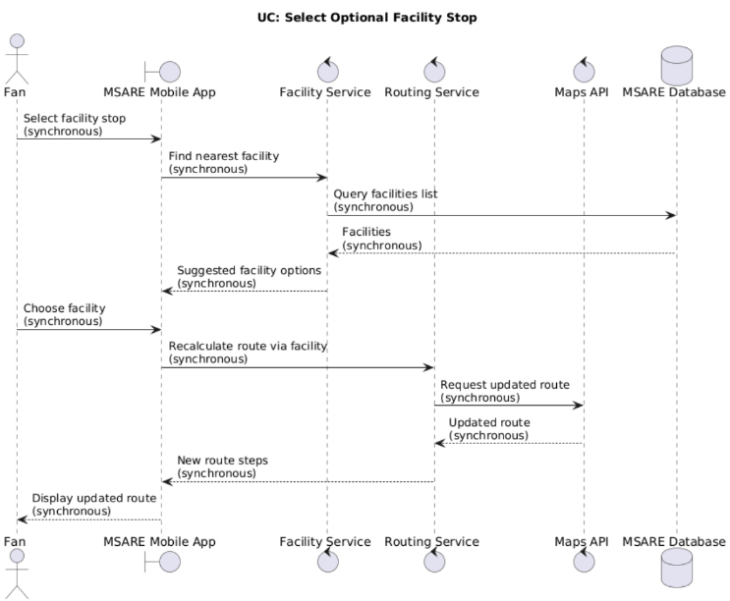

UCE 5 : Save Parking Location

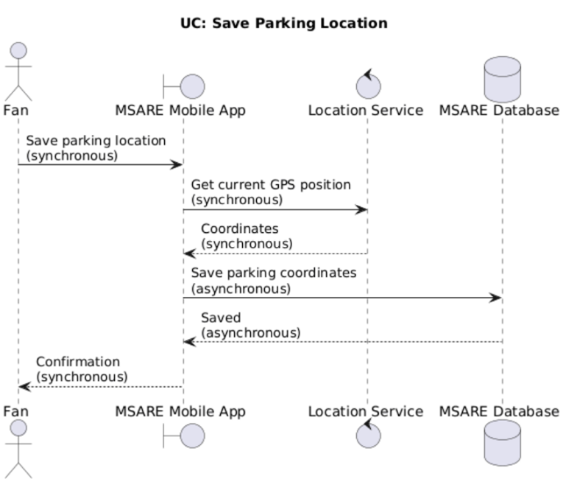

UCE 6: Save Parking Location

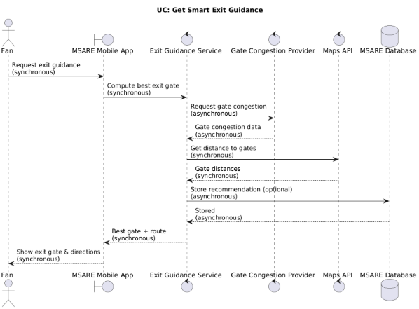

Data Storage Organization

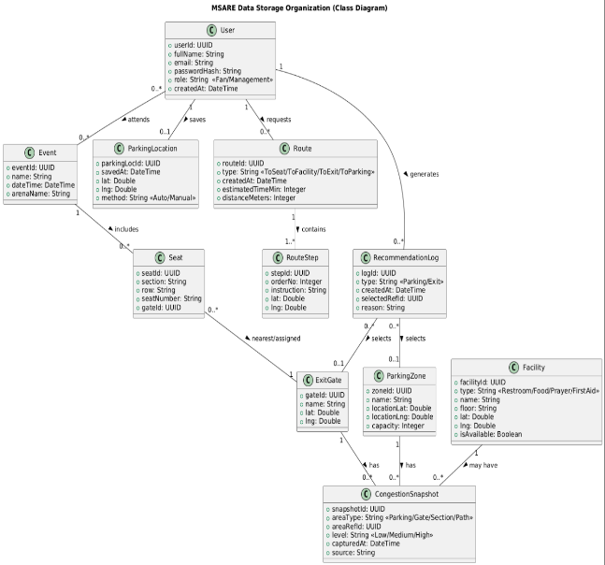

This class diagram represents the main database entities used in MSARE. It includes user data, event and seat information, parking zones and saved parking location, facility locations, routing data (routes and route steps), and real-time congestion snapshots. The relationships illustrate how users request routes and receive recommendations, while congestion data is stored for different areas such as parking zones and exit gates.

  - User Interface Prototyping (ONLY FOR PROJECT 1)
This section should explain all of the already implemented parts of the system and should also provide snapshots for the graphical user interface screens of the system

CONCLUSIONS

This project presented MSARE (Multi-System for Arena Real-time Experience), a smart system designed to enhance the experience of fans attending large stadium events. The study identified several key problems faced by stadium visitors, including difficulties in parking availability, inefficient navigation, crowd congestion, and unsafe or delayed exits after events.

To address these challenges, MSARE proposed an integrated solution that combines smart parking recommendations, indoor and outdoor navigation, real-time crowd-aware routing, optional facility stops, and intelligent exit guidance within a single system. By leveraging real-time data and user-specific information such as seat location, the system aims to improve navigation efficiency, reduce congestion, and enhance overall safety.

The proposed solution demonstrates how technology can significantly improve crowd management and user experience in large event venues. Implementing MSARE can benefit both fans and stadium management by reducing delays, improving movement flow, and increasing satisfaction during events. Future development of this project may include advanced analytics, machine learning-based prediction, and deeper integration with stadium management systems, further enhancing its effectiveness and scalability.

REFERENCES

[1] Sommerville, I. “Software Engineering”, 10th Edition, Pearson Education, 2016.

[2] Pressman, R. S., and Maxim, B. R. “Software Engineering: A Practitioner’s Approach”, 8th Edition, McGraw-Hill, 2015.

[3] Google. “Google Maps Platform Documentation”. Available at: https://developers.google.com/maps. Accessed 2025.

[4] Apple Inc. “MapKit Framework Documentation”. Available at: https://developer.apple.com/documentation/mapkit. Accessed 2025.

[5] Alahi, A., Goel, K., Ramanathan, V., Robicquet, A., Fei-Fei, L., and Savarese, S. “Social LSTM: Human Trajectory Prediction in Crowded Spaces”, Proceedings of the IEEE Conference on Computer Vision and Pattern Recognition (CVPR), 2016.

[6] Krumm, J., Letchner, J., and Horvitz, E. “Map Matching with Travel Time Constraints”, Proceedings of the Society of Automotive Engineers (SAE), 2007.

[7] OMG. “Unified Modeling Language (UML) Specification”, Version 2.5. Available at: https://www.omg.org/spec/UML. Accessed 2025.

